

“AWARENESS PROGRAMME on Intellectual property Rights
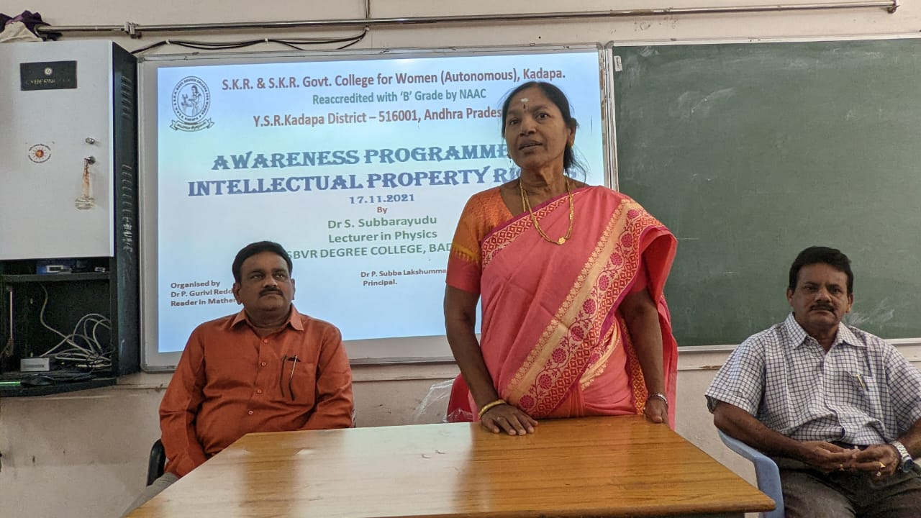

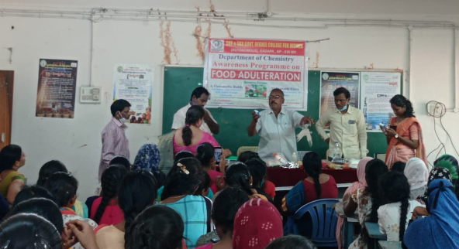
TOPIC: Intellectual Property Rights
Date: 17.11.2021
No. of Students Participated: 60
Class: II B.Sc Students
Resource Person: Dr. S. Subba Rayudu,
Lecturer in Physics,SBVRDC (M), Badvel.

Synopsis of the Topic : Intellectual property
rights (IPR) refers to the legal rights given
to the inventor or creator to protect his
invention or creation for a certain period
of time. These legal rights confer an
exclusive right to the inventor/creator or
his assignee to fully utilize his
invention/creation for a given period of time.

Principal :
Dr. P. Subbalakshumma, M.com,
M.Phil, Ph.D.

Feedback: Excellent

Organised by
Dr P. Gurivi Reddy,
Reader in Mathematics.

Faculty involved: Faculty of Mathematics
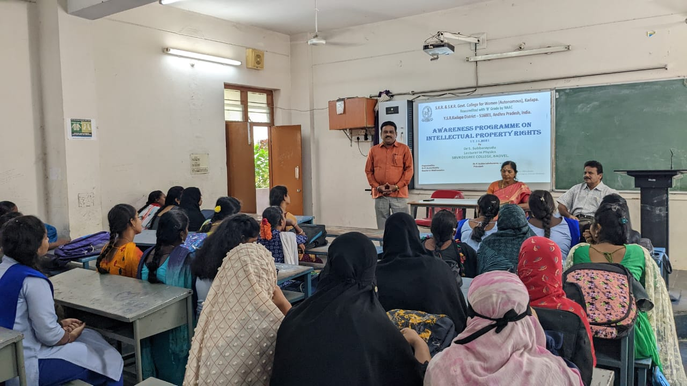

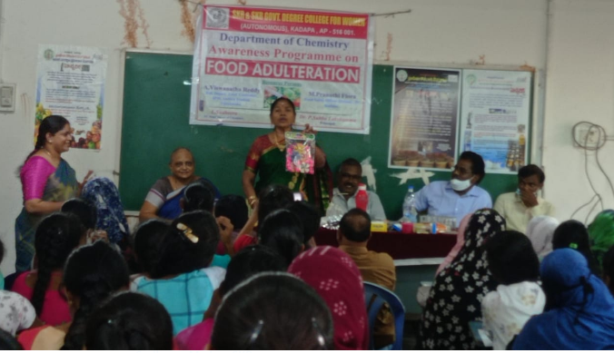

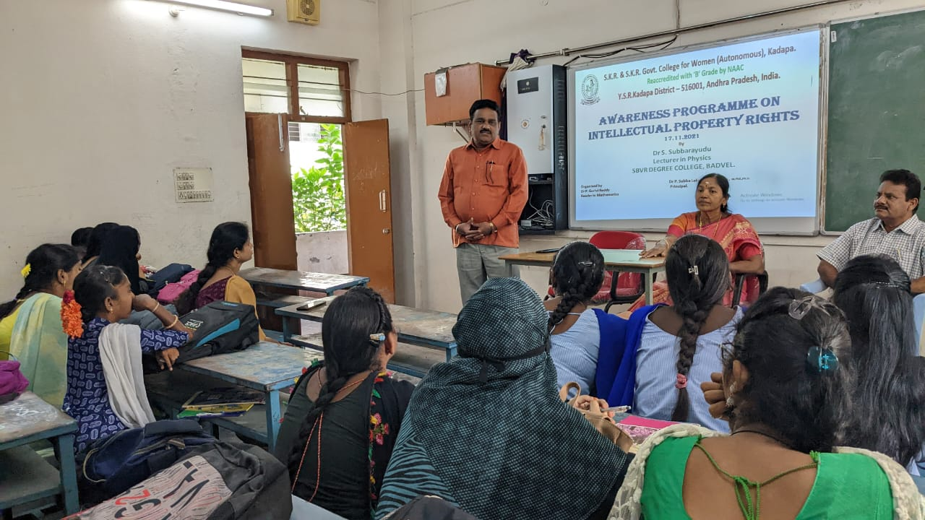

“WORKSHOP on Research Methodology”
TOPIC: Research Methodology
Date: 27.11.2021
No. of Students Participated: 70
Class: II BSc Students
Resource Person: Dr. S. Nagendra,
Lecturer in Mathematics,GDC (M), Kadapa

Synopsis of the Topic : Research methodology
is the specific procedures or techniques
used to identify, select, process, and
analyze information about a topic.
In a research paper, the methodology
section allows the reader to critically
evaluate a study's overall validity and
reliability.

Principal : Dr. P. Subbalakshumma, M.com,
M.Phil, Ph.D.

Feedback: Excellent

Organised by
Dr P.. Gurivi Reddy,
Reader in Mathematics

Faculty involved: Faculty of Mathematics
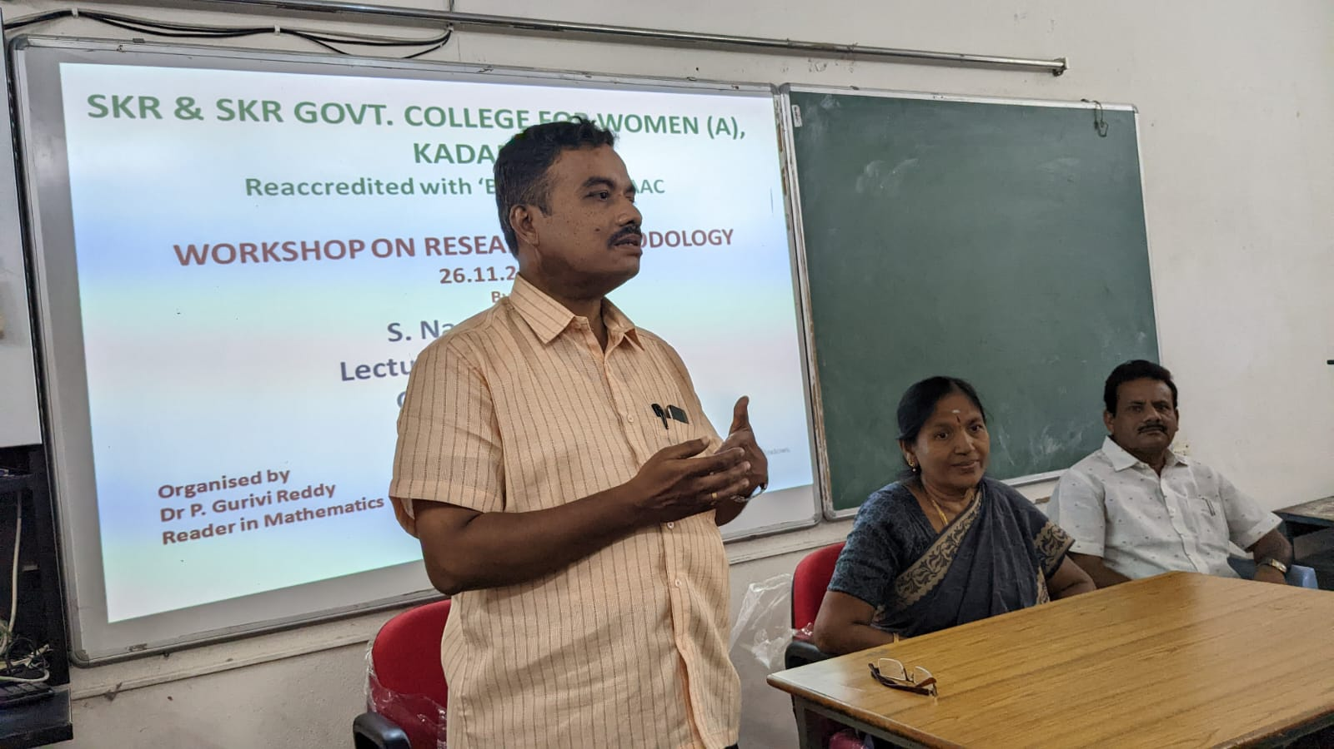

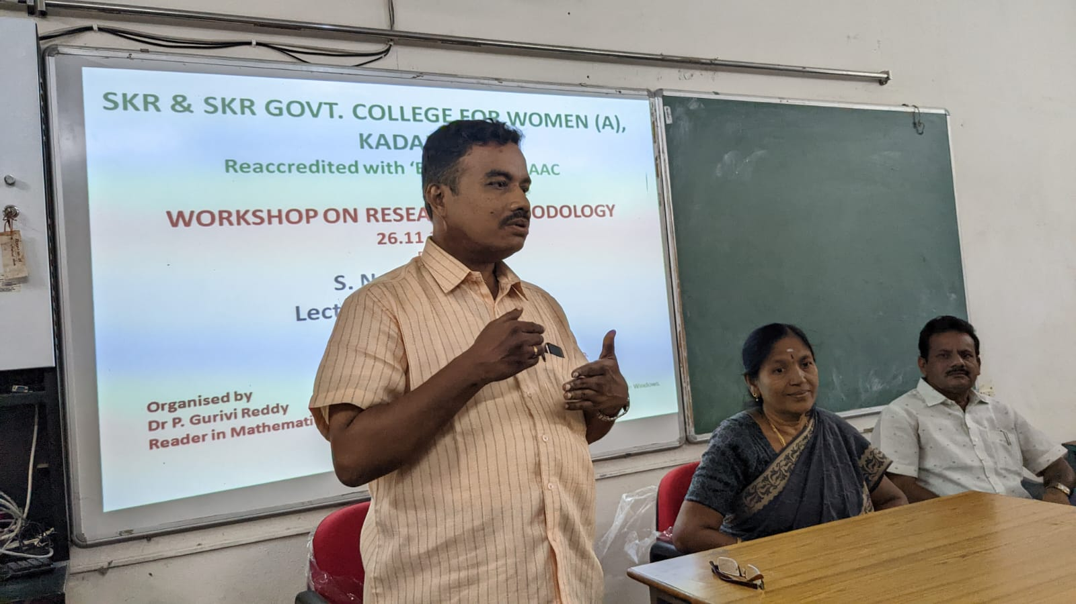

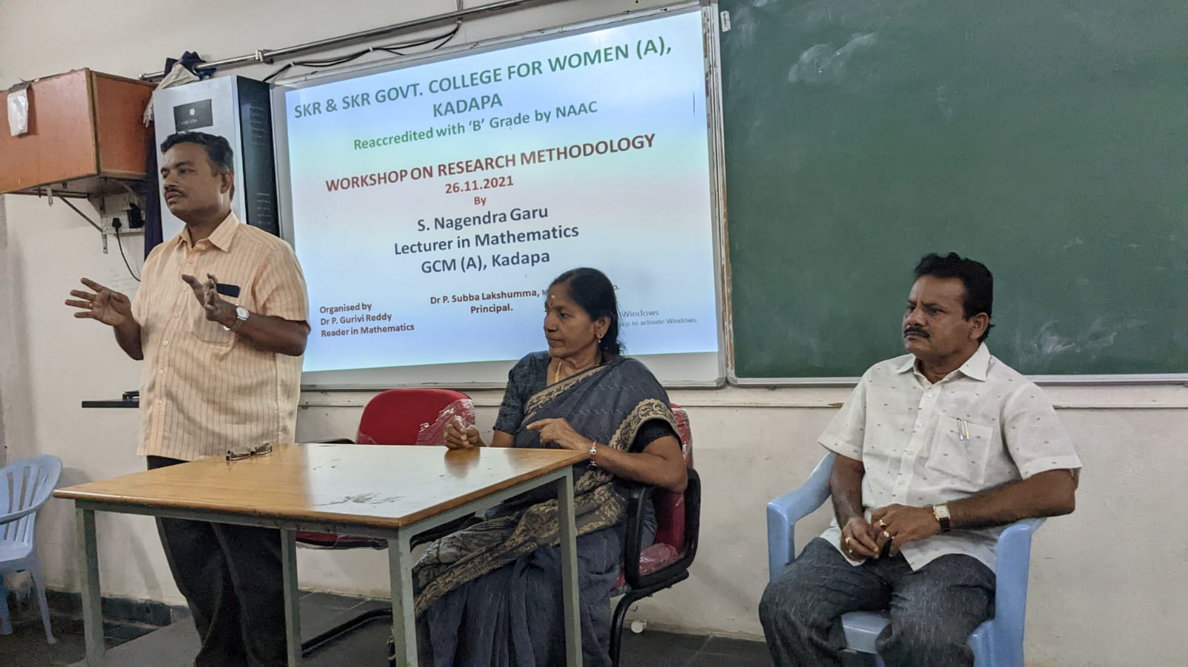
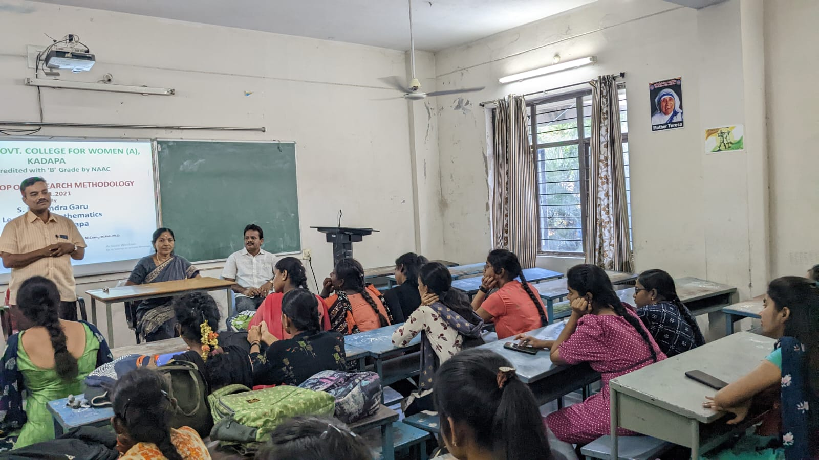

“LIFE SKILL COURSE”
TOPIC: Entrepreneurship

No. of Students Participated: 60
Class: I BCom Students
Resource Person: V. Aruna,
Lecturer in Commerce,GDC(W), Kadapa.

Synopsis of the Topic : Entrepreneurship is the
creation or extraction of economic value. With this
definition, entrepreneurship is viewed as change,
generally entailing risk beyond what is normally
encountered in starting a business, which may
include other values than simply economic ones.

Principal : Dr. P. Subbalakshumma, M.com,
M.Phil, Ph.D.

Feedback: Excellent

Faculty involved: Faculty of Commerce

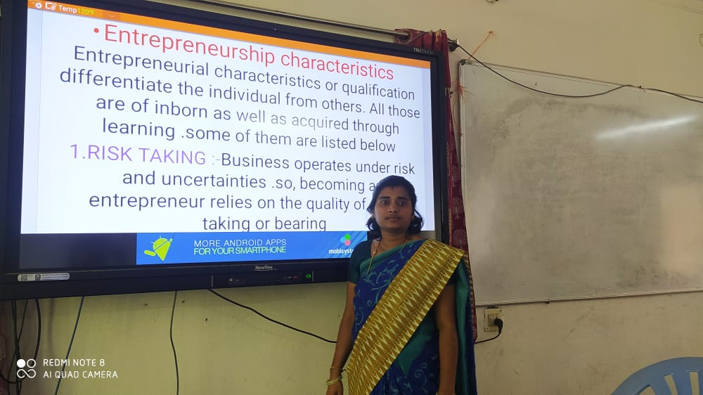

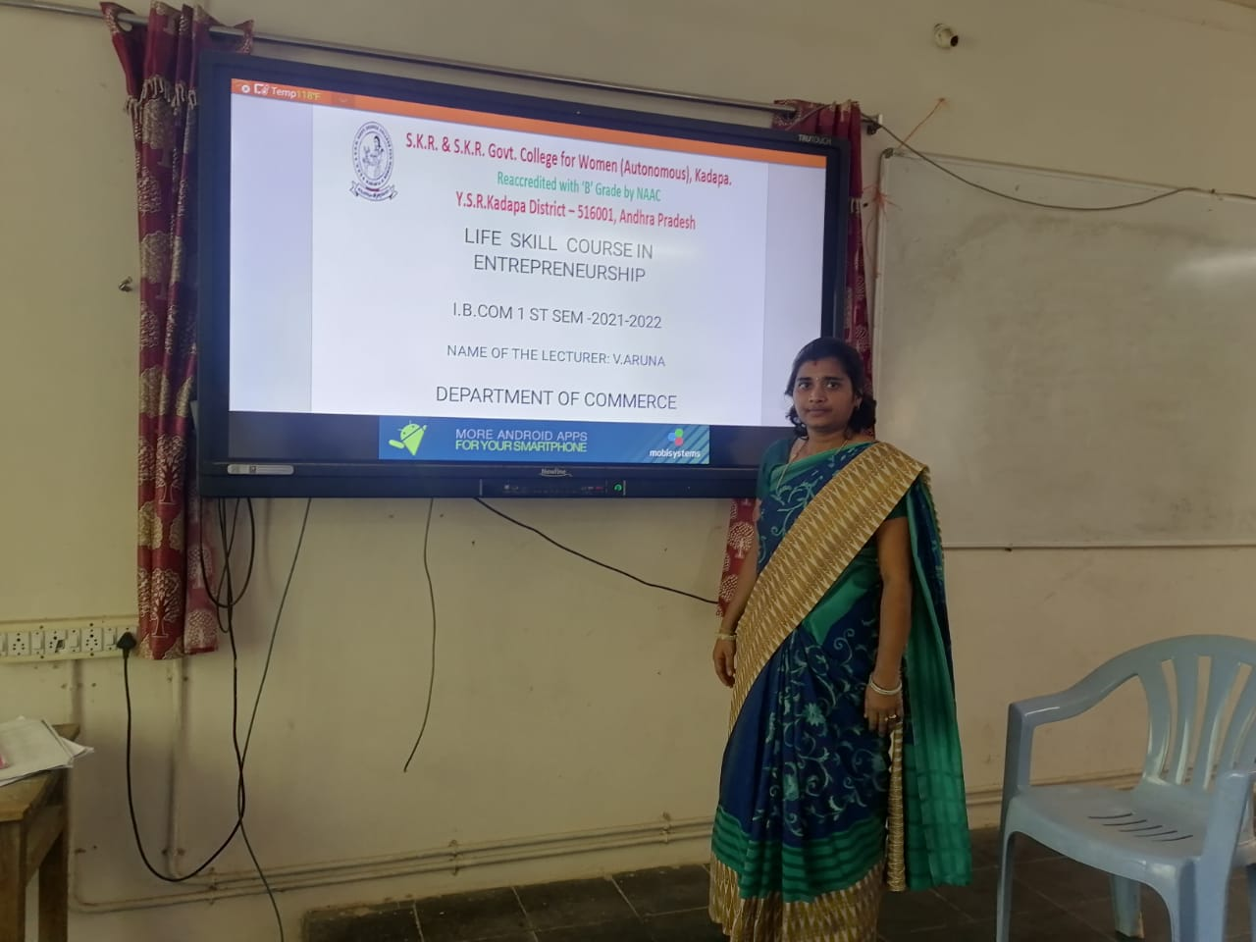

“Skill Development Programme”
TOPIC: Analytical Skills

No. of Students Participated: 60
Class: II BSc Students
Chief Guest: K. Shalini,
Lecturer in Mathematics, Kadapa

Synopsis of the Topic : Analytical skill is the
ability to deconstruct information into smaller
categories in order to draw conclusions. Analytical
skill consists of categories that include logical
reasoning, critical thinking, communication,
research, data analysis and creativity

Principal : Dr. P. Subbalakshumma, M.com,
M.Phil, Ph.D.

Feedback: Excellent

Faculty involved: Faculty of Mathematics

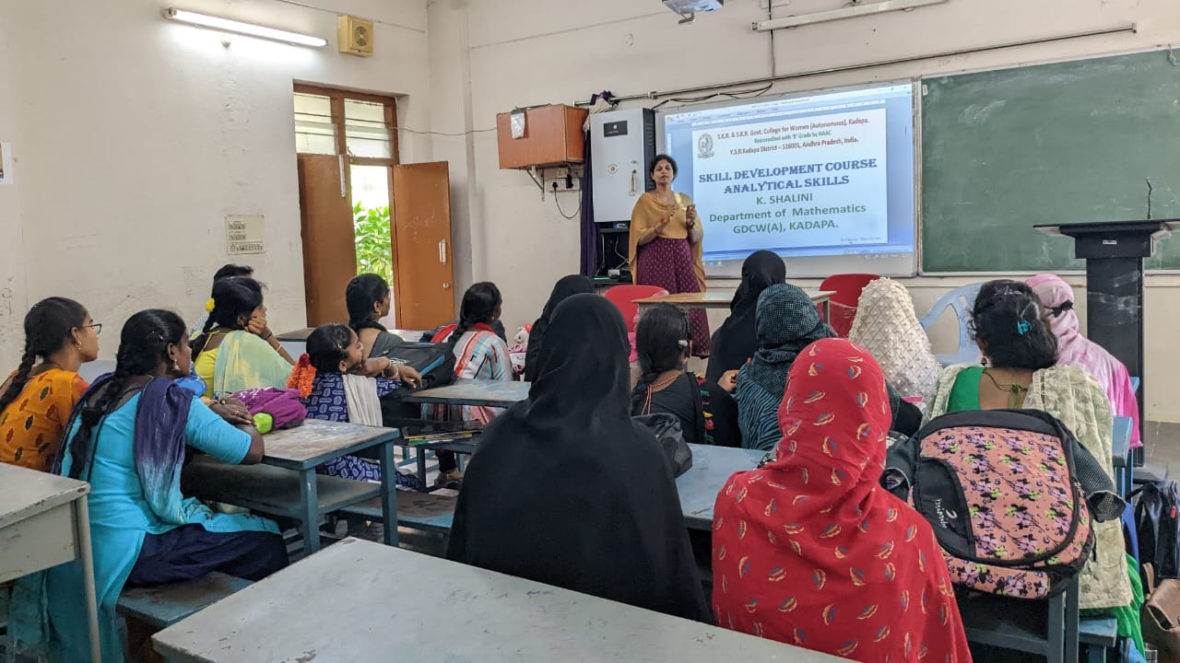
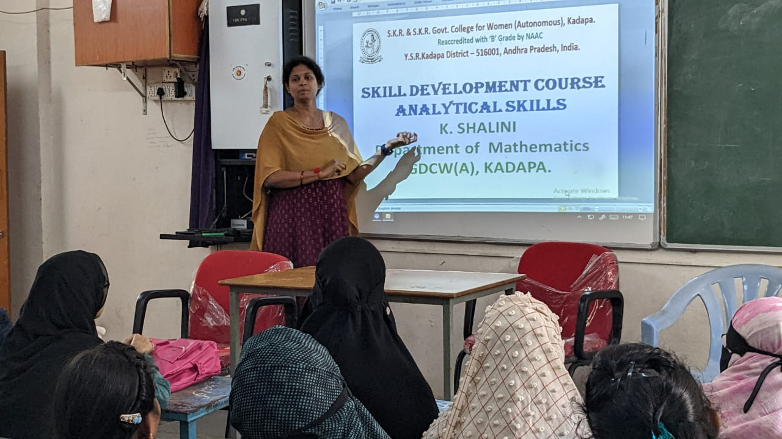

“Skill Development Programme”
TOPIC: Analytical Skills

No. of Students Participated: 60
Class: II BSc Students
Chief Guest:Dr P. Gurivi Reddy
Reader in Mathematics, Kadapa

Synopsis of the Topic : Analytical skill is the
ability to deconstruct information into smaller
categories in order to draw conclusions. Analytical
skill consists of categories that include logical
reasoning, critical thinking, communication,
research, data analysis and creativity

Principal : Dr. P. Subbalakshumma, M.com,
M.Phil, Ph.D.

Feedback: Excellent

Faculty involved: Faculty of Mathematics
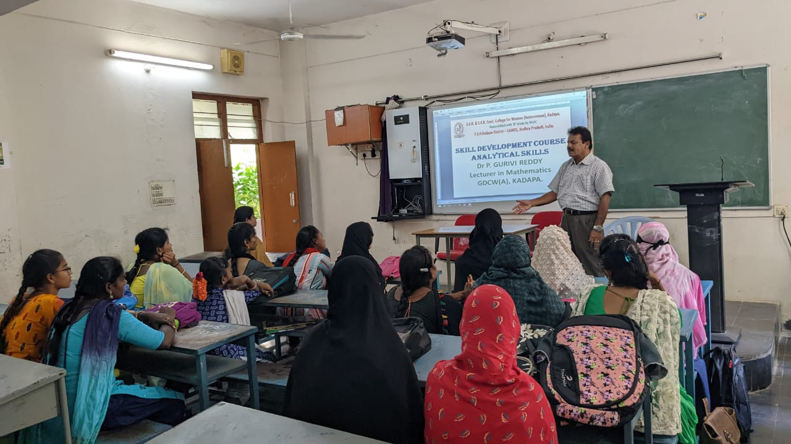

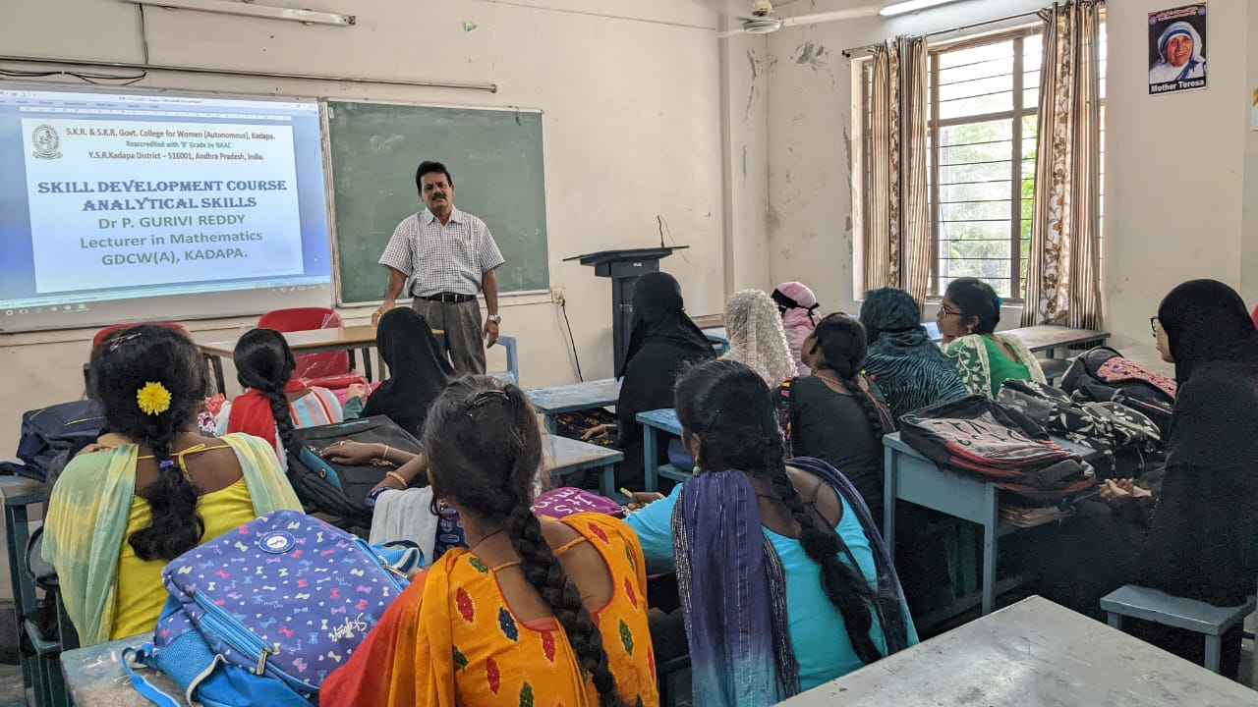
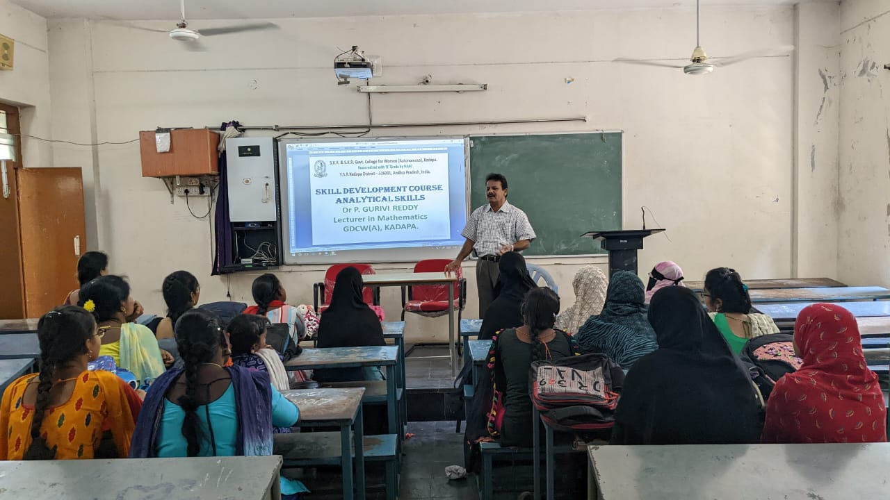
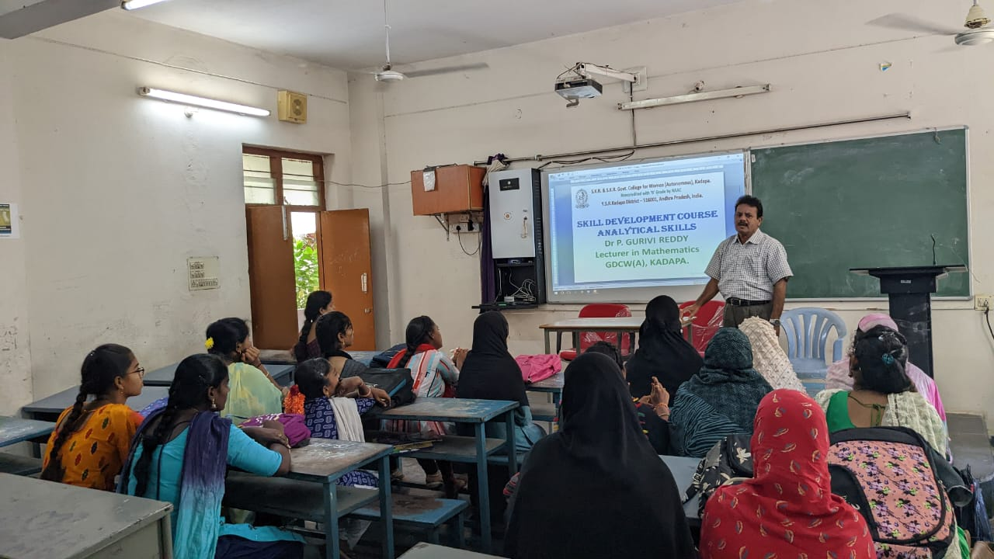

“Skill Development Programme”
TOPIC: Self Employment Skills

No. of Students Participated: 100
Class: II BA Students
Chief Guest: N. Narayana Reddy, Director
Canara Bank, Kadapa

Synopsis of the Topic : Awareness about self
employment and rural entrepreneurship
Courses offered in RSETI are 1. Tailoring
2. Embroidery 3. Beauty Parlor Management
4.Photography 5. Candles Manufacturing
6. Jute Bags Manufacturing 7. Cell Phone
Repair & Service. Loan Facility to new
entrepreneurs

Principal : Dr. P. Subbalakshumma, M.com,
M.Phil, Ph.D.

Feedback: Excellent

Faculty involved: Faculty of Arts.
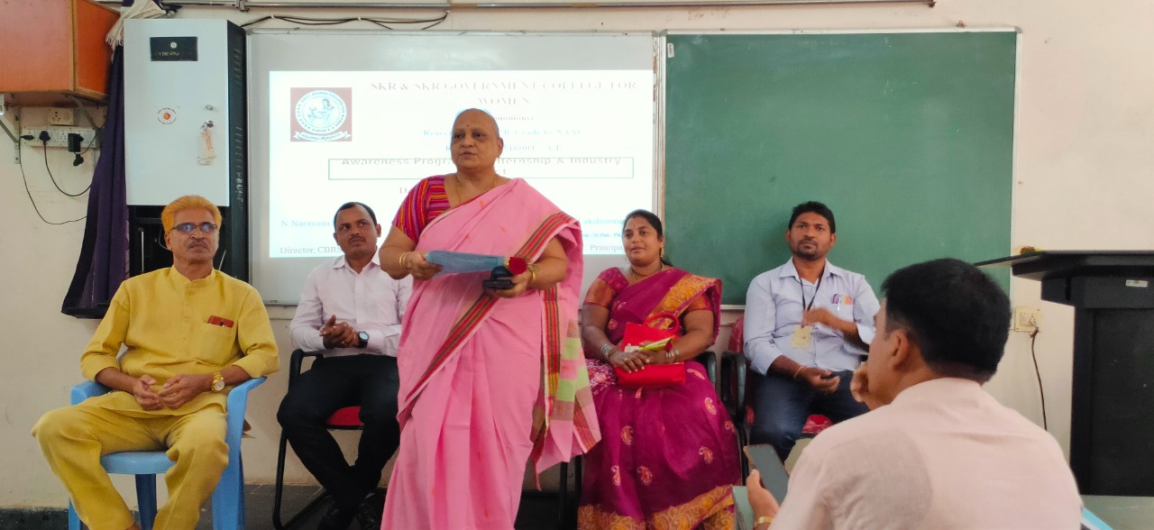

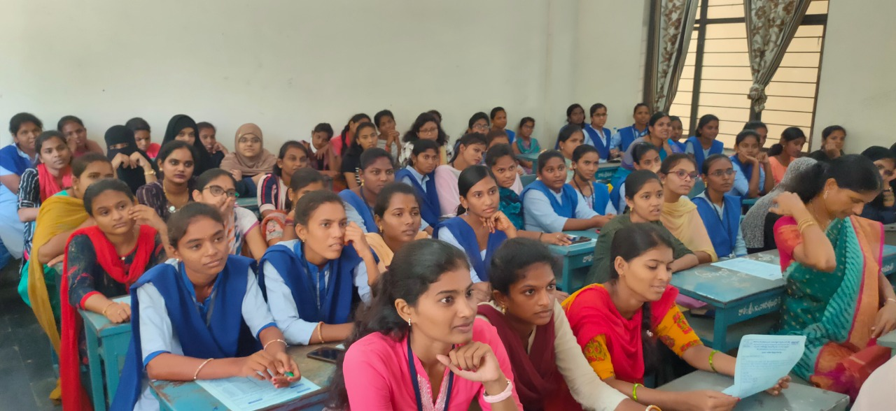

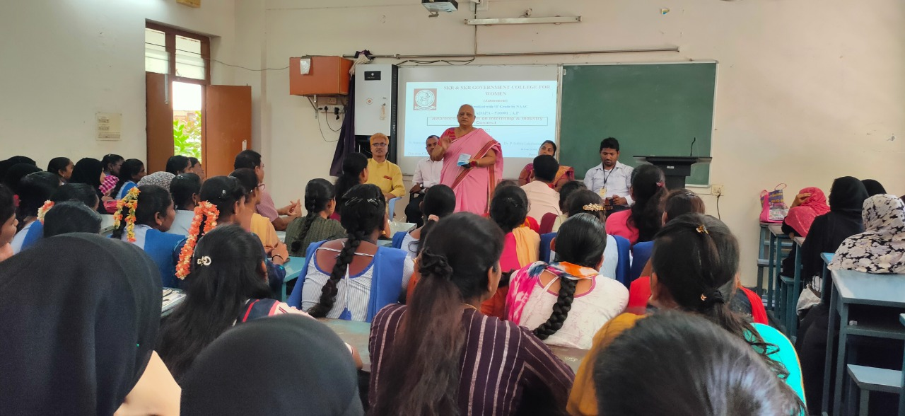
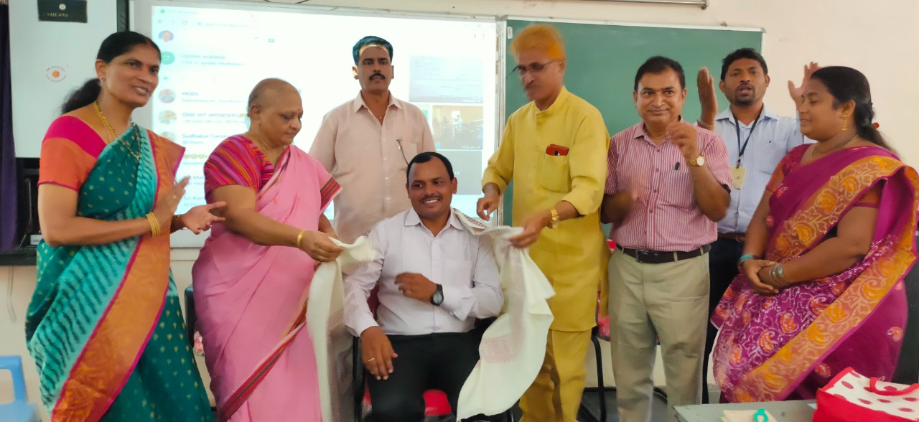

DEPARTMENT OF MICROBIOLOGY
SKILL DEVELOPMENT COURSE
PLANT NURSERY
TOPIC: PLANT PROPAGATION
By: Dr. B. PRIYADARSINI

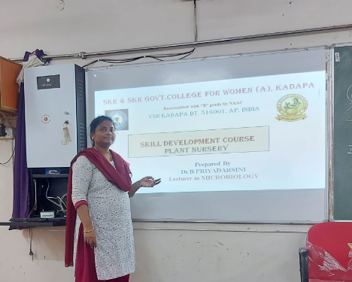
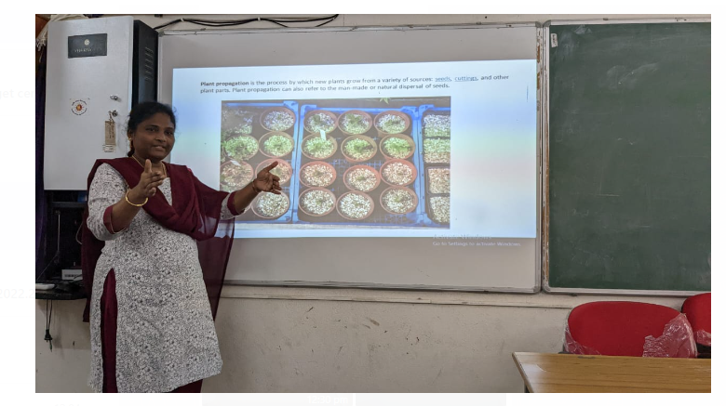

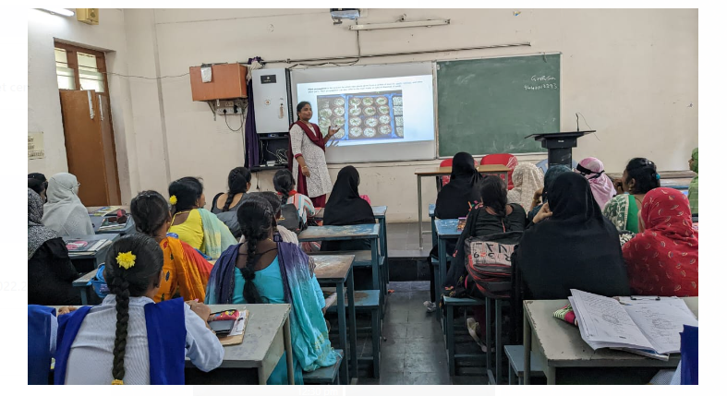

Department of Botany
Skill Development course
Plant Nursery
Topic: Containers used in plant nursery
By: Dr.P.Subramanyam

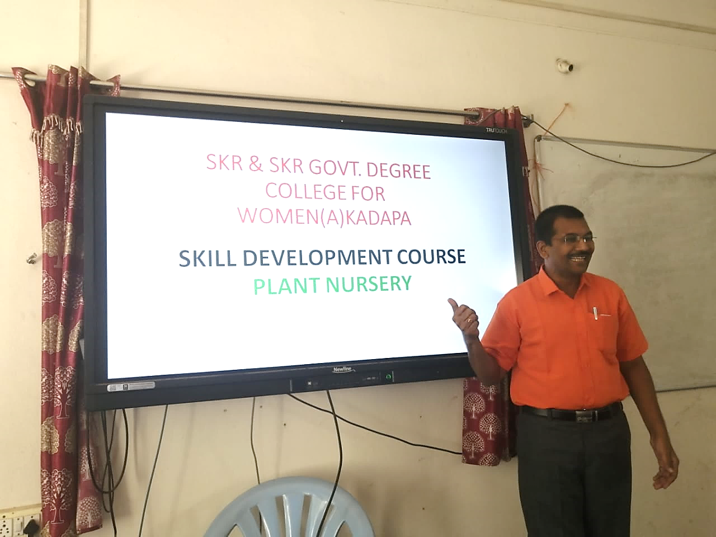

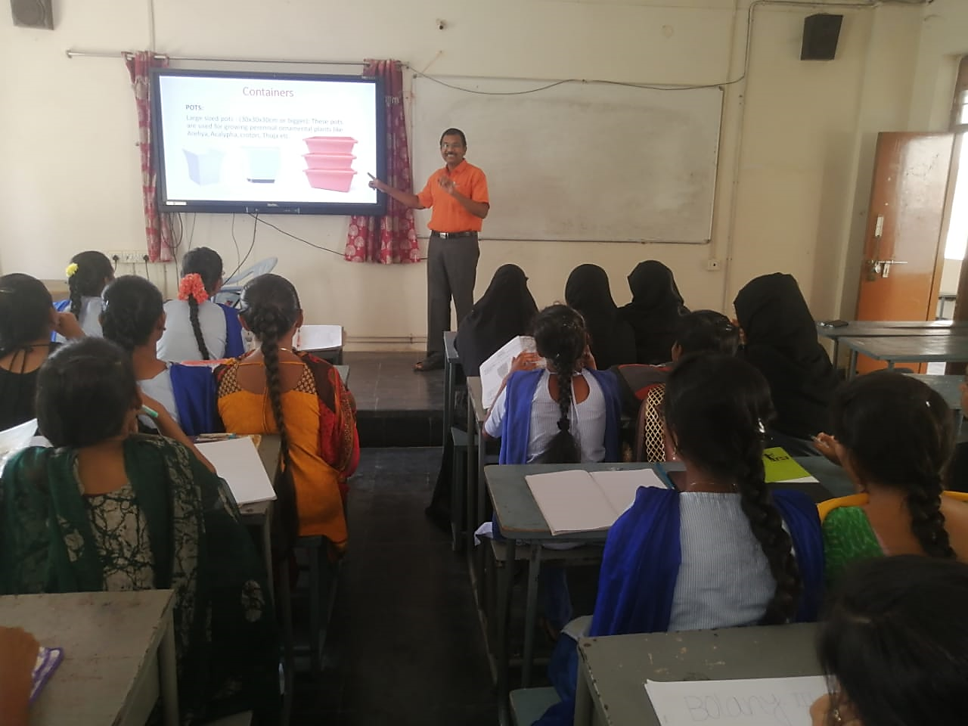
Department of Botany
Skill Development course
Plant Nursery
Topic: Growing Media
By: Smt. B.Yugavani

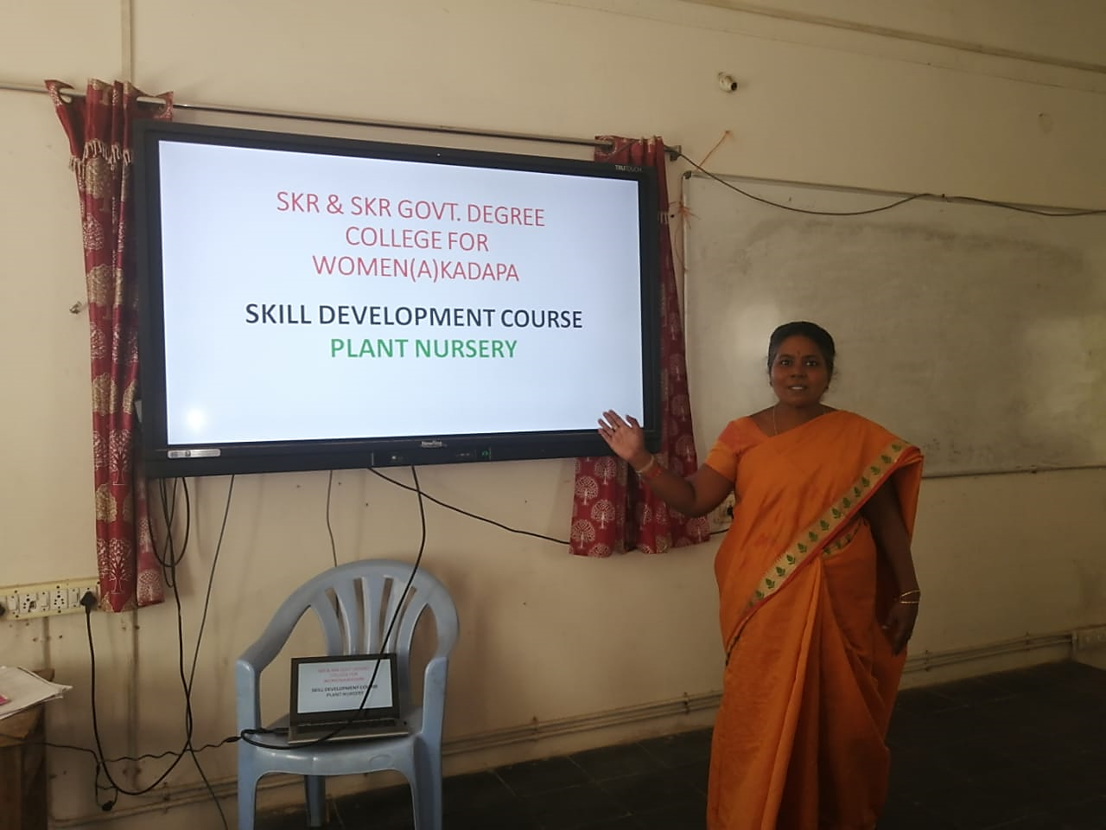
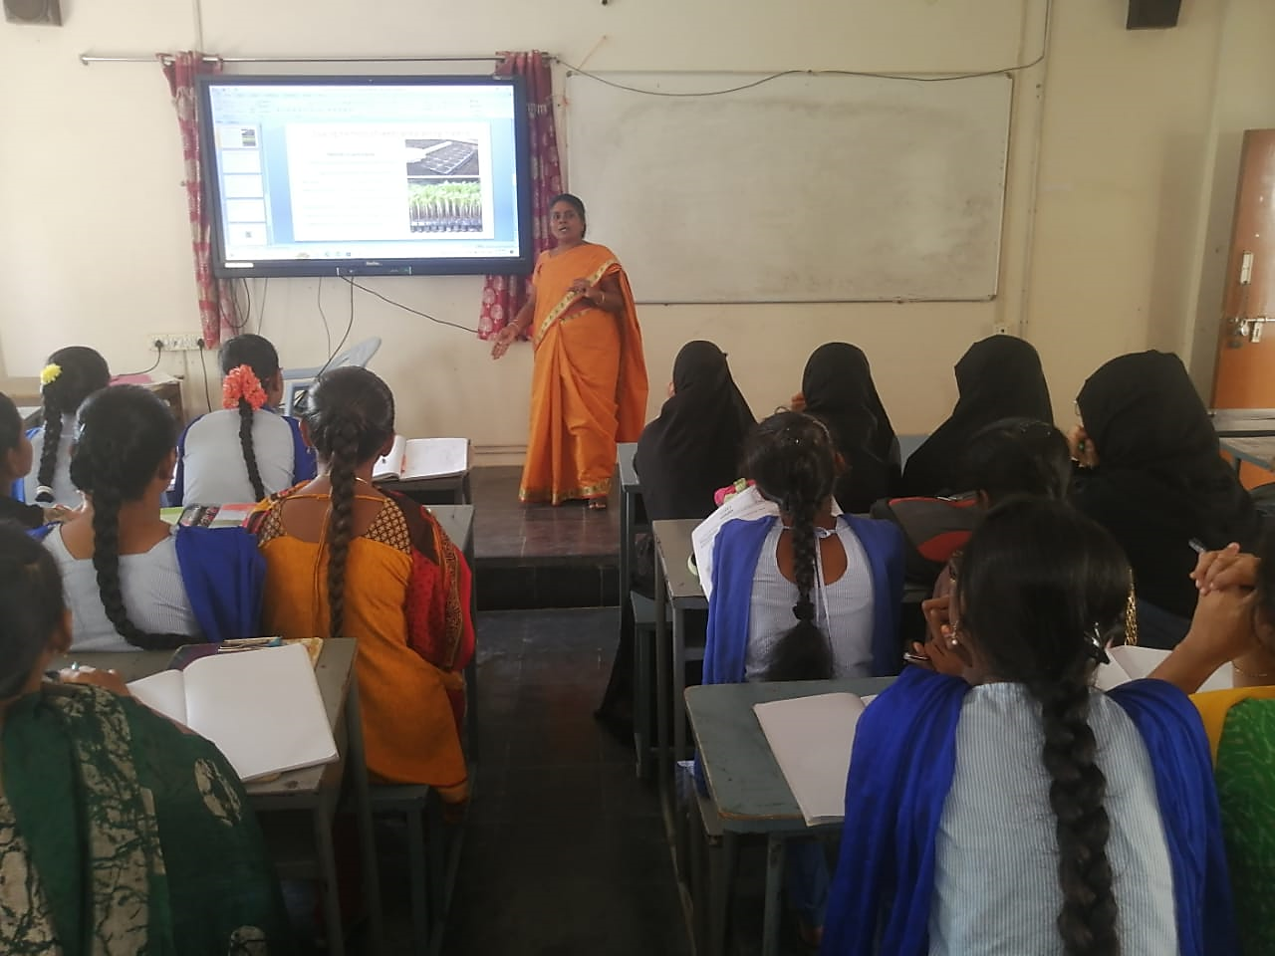
Department of Botany
Skill Development course
Plant Nursery
Topic: Vegetative Propagation
By: Smt. Y.Nagarahnamma

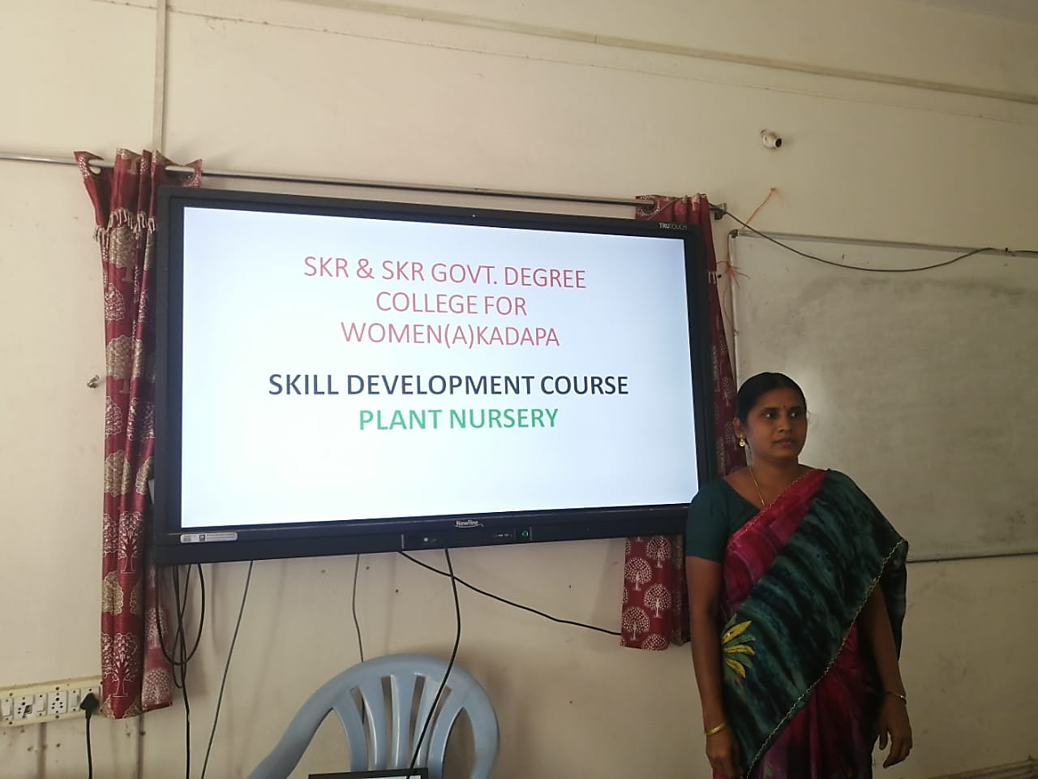
Environment Education
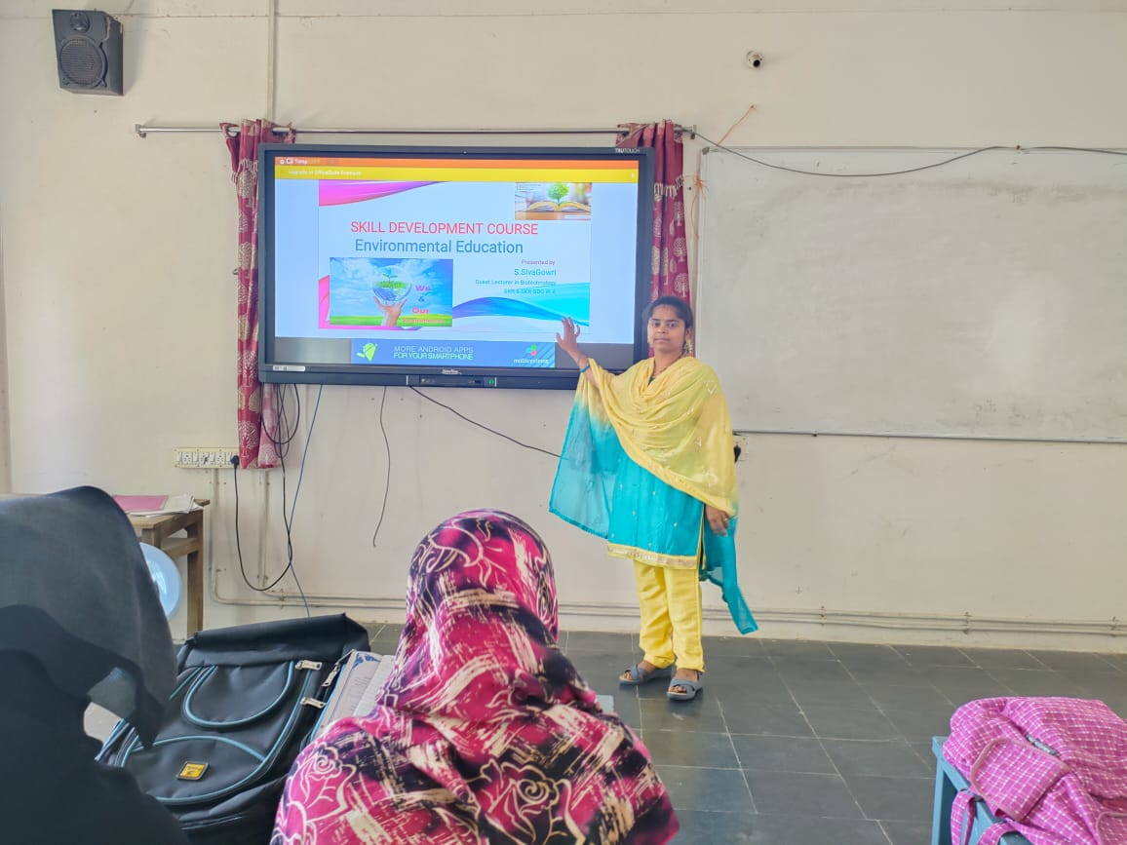
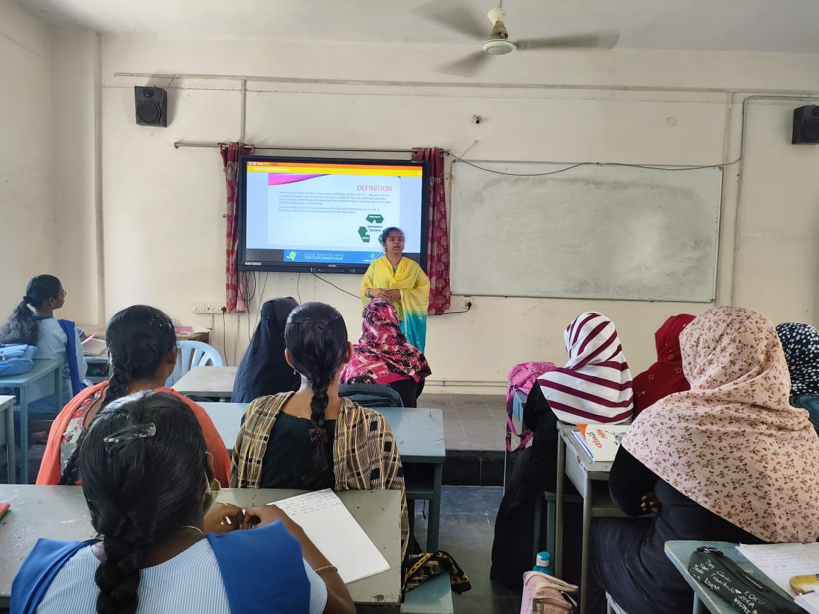

SOLAR ENERGY
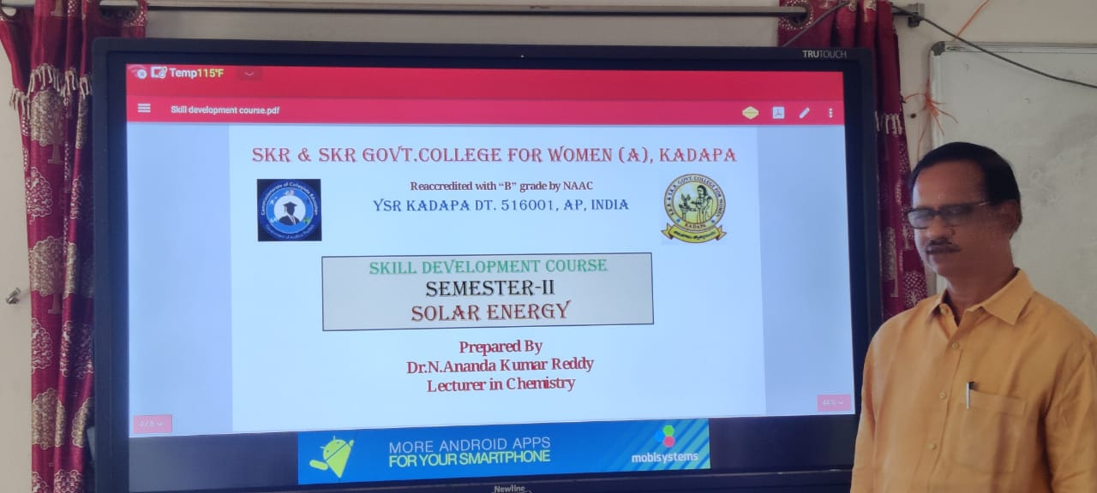

DIARY TECHNIQUES
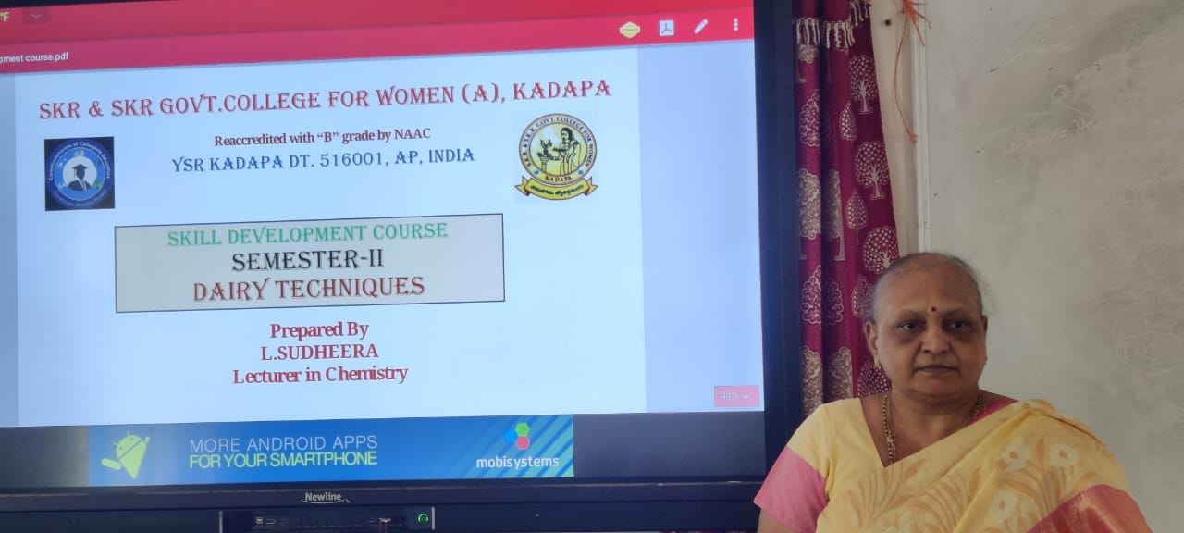

POULTRY FARMING
